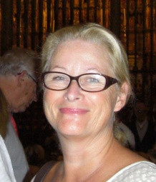

Alix Jauffret Sèvres, 16th May 2016
Passeriphane Cavaliers
2, parc des Jardies
92310 SEVRES
FRANCE

You will find here after a few words about myself.

I am a DOG LOVER, as far as I can remember I always shared my life with dogs. As a child my soul mate was an English Cocker Spaniel.

I am an old breeder, I have been breeding Cavaliers for more than 20 years now and made 21 Champions de France.

I love four colors but my favorite are wholecolors. A few years ago it seemed to me that becoming an FCI Judge would be a good way to stay in the world of dogs and keep an eye on the breed as well if... someday... I would stop breeding (which will happen of course)!

I was lucky enough to judge many Specialties in France and already three times at the French Club Show itself. I proud myself to have judged already in Germany, Estonia, Belgium, Sweden, Denmark, USA (Carmel CA) and (Matamoras PA), Finland, Italy, Australia, New Zealand and in France as well of course. It was my pleasure too, to be invited at the first Club Show of O.KA.E Cavalier King Charles Club of Greece.

I am allowed to judge Cavalier King Charles, King Charles, Poodles, Pekinese, Chins and Chihuahuas at International Shows.

Last but not least, I have been happily married to Patrice for 48 years, I am lucky mother of 7 (six boys one girl) and proud grandmother of 12.

I am looking forward to this very special time in your lovely country and I feel very honored to be invited to share with you this special event of your Club Show. I am looking forward to meeting you all and your lovely dogs.

All the best.

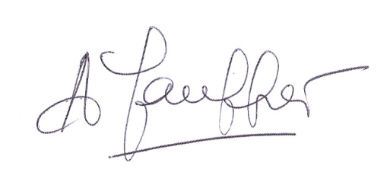

Alix Jauffret
Passeriphane Cavaliers
France

